Earth & Environmental Sciences

Guide to a graduate degree

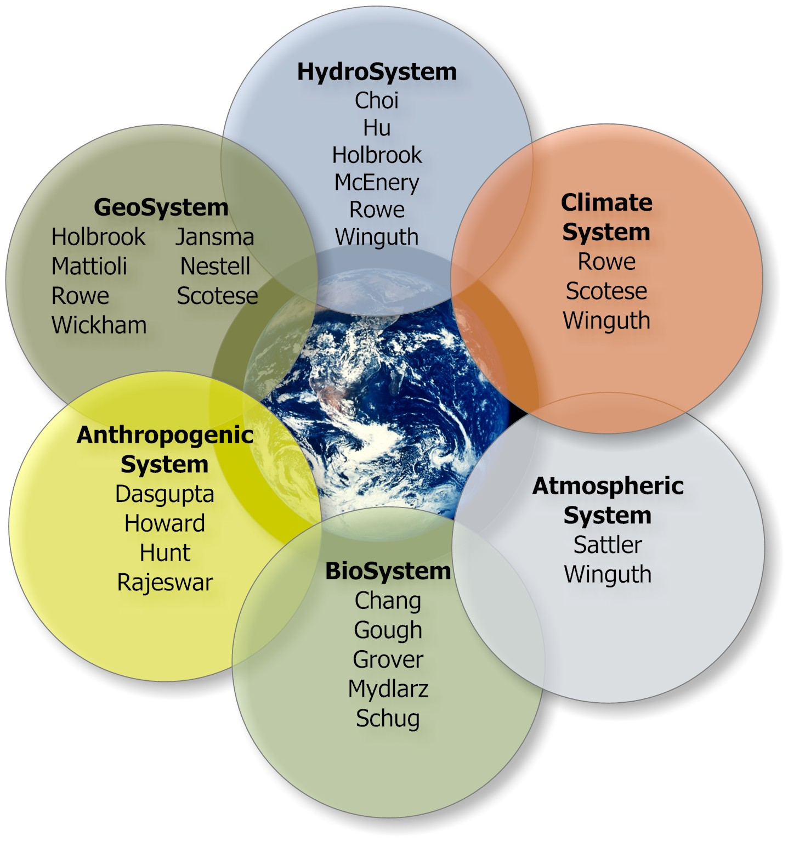

Guide to A Graduate Degree
Department of Earth & Environmental Sciences

TABLE OF CONTENTS

INTRODUCTION 3
RULES, REGULATIONS AND POLICIES ------------------------- 3
REGISTRATION, COURSE SELECTION AND ADVISING 5
STEPS LEADING TO COMPLETION OF A MS DEGREE 6
STEPS LEADING TO COMPLETION OF A PhD DEGREE -- 8
THESIS/DISSERTATION PROPOSALS ----------------------------10
MENTORING PROGRAM -----------------------------------------------11
DUAL DEGREE PROGRAM --------------------------------------------12

INTRODUCTION
The following Guidelines summarize the policies and regulations of the Graduate School and the Graduate Studies Committees of the Department of Earth & Environmental Sciences of The University of Texas at Arlington. In addition, the Guidelines contain an outline of requirements for completion of the MS degree in Geology, the MS degree in Environmental & Earth Sciences, and the PhD degree in Environmental & Earth Sciences.
It is the responsibility of each graduate student to be familiar with the general regulations of the Graduate School and the specific regulations of the Department of Geology that pertain to graduate education. Information regarding these regulations can be found in the Graduate Catalog (http://www.uta.edu/gradcatalog/toc.php). Graduate school deadlines for submitting theses, examination results and applications for graduation are listed in the Graduate School Calendar (http://grad.uta.edu/about/calendar/ ).

RULES, REGULATIONS AND POLICIES
General
Graduate School rules and regulations for MS and PhD programs can be found at this URL: http://www.uta.edu/gradcatalog/2011/general/regulations/. The following represents the department’s implementation of these rules.
The MS in Geology requires 24 hours of coursework and a thesis. Students must select a thesis committee, consisting of a faculty supervisor and two other faculty members, during the first semester of residence. Courses are selected by the student in consultation with the faculty supervisor or the graduate advisor, and the courses must be approved by the thesis committee during the first year in residence. In addition, students must write and defend a thesis proposal during the first year of residence. The thesis committee will also serve as an examining committee for the thesis proposal and the MS comprehensive examination. Students who do not have the undergraduate prerequisites for graduate study in Geology may be required to take them as course deficiencies.
The MS in Environmental and Earth Sciences has thesis, non-thesis and professional options. The thesis option requires a thesis plus 32 hours of coursework. The non-thesis and professional options requires 38 hours of coursework. For all options, students take 15 semester credit hours of core courses in environmental science, engineering, and policy, and sufficient hours of elective courses to meet degree requirements. For the professional option, students must take a course on economics, participate in mentoring, and complete an internship and research project. Elective courses are selected by the student in consultation with the faculty supervisor or the graduate advisor. All MS students take a comprehensive exam before graduation and an examining committee of at least 3 faculty members should be selected in consultation with the graduate advisor or thesis supervisor. Students in the non-thesis option take a comprehensive exam over their course work, and students in the thesis option usually answer questions about their thesis after a short presentation. Students who do not have the undergraduate prerequisites for graduate study in Environmental and Earth Sciences may be required to take them as course deficiencies. These courses must be completed within one year of enrolling in the program, unless permission to do otherwise is obtained Chair of the Graduate Studies Committee. Deficiency courses may be taken at community colleges.
The PhD degree in Environmental and Earth Sciences is a research degree and requires a dissertation consisting of original research. In general, a student will not be accepted into the PhD program unless a faculty member has agreed to serve as mentor. During the first year of residence, the student must select a research advisor (who may be the mentor) and four additional members of the faculty to serve as the examining committee. During the first year, the examining committee will administer a diagnostic exam designed to discover student strengths and weaknesses. The exam will be used to design and approve a course program for the student. After the course work is completed and after a dissertation proposal has been submitted, the examining committee will administer the comprehensive examination. Generally the dissertation proposal will be presented orally at the comprehensive examination and be part of the examination.

Residency.
For the MS degrees, no more than 9 hours of graduate course work from another institution may be applied to an MS degree from UTA. In addition, at least 18 hours of graduate course work must be completed at UTA. Transfer credit is given only upon approval of the Graduate Studies Committee and the Graduate Dean. Only courses appropriate to the UTA Masters program will be accepted.
For the PhD degree, there are no specific residency requirements. The PhD supervisor and examining committee determine the number of courses that can be transferred.

Time Limits, Assistantships, and Office Space.
The master's degree must be completed within six years from the student’s initial registration in the Graduate School. The Graduate Dean may grant extensions to this time limit after a positive recommendation by the Graduate Studies Committee of the Department.
All requirements for the doctoral degree must be completed within four years after the student unconditionally passes the comprehensive examination. The Graduate Dean may grant extensions to this time limit after a positive recommendation by the Graduate Studies Committee of the Department.
All graduate students receiving financial support through Graduate Assistantships (GA’s) must take at least 9-credit hours/semester. MS students normally receive support for a maximum of four academic semesters (summer semesters excluded). PhD students normally receive support for a maximum of six academic semesters (summer semesters excluded).
Assistantships are available only for students in good standing. Students on probation or on provisional status are normally not eligible for a graduate assistantship.
GA’s have first priority for office space and then those involved in thesis/dissertation research. But as a general rule MS students should not expect to have access to office space beyond the third year of residency and PhD students beyond the fourth year of residency.

Courses and grade requirements
All MS and PhD students take graduate courses (Numbers 5000 – 6999). With approval of the student’s committee, up to 25% of the course work may be senior-level undergraduate courses (numbers 4000 - 4999). To remain in good standing, students must maintain a B average, GPA of 3.0 or better each semester. For graduate students, a D is considered a failing grade and the course cannot be used for degree requirements.
For Geology MS students, two semesters of Geology 5199, the speaker series, is required. The two credit hours count toward the required 24 hours of course work, but only 1 credit hour of research coursework may be applied to the 24 credit hour requirement.

Thesis.
Students in a MS thesis program must enroll for 3, 6, or 9 semester hours of thesis (GEOL 5398, 5698, or 5998 or EVSE 5398, 5698, or 5998) during each term thesis research is conducted, and must be enrolled for 6 hours of thesis during the semester they successfully defend the thesis and pass the final oral exam.
Students in the PhD program must enroll in Dissertation hours (EVSE 6399, 6699, or 6999) while working on dissertation research, and must be enrolled in 6 hours of dissertation during the semester they successfully defend the dissertation.

Final Examination.
For the MS Thesis option, students present the results of their research to the Examining Committee and respond to their questions after submitting the written thesis to the committee. By majority vote, the committee may pass, fail, or defer the student.
For the non-thesis and professional options, the final exam is over coursework. The examination may be oral, written or both at the discretion of the examining committee. By majority vote, the committee may pass, fail, or defer the student.
For the PhD program, the final exam is an oral defense of the dissertation. By majority vote, the committee may pass, fail, or defer the student.

REGISTRATION, COURSE SELECTION AND ADVISING
Registration in graduate courses MUST be CONTINUOUS from the time of first registration unless a leave of absence is granted. Otherwise the student will be dropped from the Graduate School and will have to reapply to be reinstated.
A full course load for graduate students is 12 semester hours. Students with half-time teaching or research assistantships must take a minimum of 9 credit hours. Geology MS students must register for two semesters in Geology 5199 (Technical Sessions), so their student assistant course load is normally 10 hours during those two semesters.
The graduate advisor and/or faculty supervisor (when selected) will advise and approve student course work before registration each semester.
Students entering the program on probationary status must maintain a B average (3.0 GPA) over the first 12 hours of course work. Probationary students who do not have a 3.0 GPA after the first 12 hours will be dismissed. Students not on probation who do not maintain a 3.0 GPA will be placed on probation and have one semester to raise their GPA to 3.0.
Students entering the program under provisional status are required to supply the graduate School with complete and satisfactory credentials before the end of their first semester.
If a student wishes to drop a course, the faculty supervisor and the Graduate Advisor must approve.

STEPS LEADING TO COMPLETION OF A MASTER'S PROGRAM

- Before registration for courses, each student is advised by the faculty supervisor (if known) and/or the graduate advisor.
- By the end of the first semester.
  - Remove any provisional admission contingencies (e.g. GRE scores, transcripts, or other requirements).
  - Interview appropriate faculty members to become familiar with their research interests and select a faculty supervisor and examining committee. Scientists from other universities or industry may serve on the supervisory committee in addition to UTA members. The members of the supervisory committee are available for advice and will conduct the final comprehensive examination.
  - Complete an approved Tentative Program of Work listing all transfer courses, courses in progress, and courses you plan to take. The Program of work should be discussed with the faculty supervisor (if known) and the Graduate Advisor.
- By the end of the second semester:
  - If in the thesis option, select a topic for thesis research and write a thesis proposal in consultation with the faculty supervisor.
  - In if the non-thesis option, no research topic is necessary.
  - If in a thesis option, give a copy of the thesis proposal and the program of work to the supervisory committee and arrange a formal meeting with the supervisory committee. Present the proposal as a formal talk and answer any questions from the committee. The committee will approve the proposal and program of work or make/suggest changes to either. After approval the proposal and program of work will be signed by the committee members and given to the graduate advisor and placed in the student’s file.
  - Complete all academic deficiencies listed on the Notice of Acceptance to Graduate School.
- The semester in which organized thesis research begins:
  - Register for thesis credit hours (Geology 5398, 5698, or 5998). Graduate School Regulations stipulate that students must register for thesis research each semester that research or editing of the thesis is in progress. This regulation applies whether students are in residence or not. Summer registration is required if any University facilities are used, or if the thesis supervisor is actively involved.
  - It is the desire of the Department to support thesis research to the extent to which financial and equipment resources are available. This support includes access to all analytical equipment, computing facilities, scanning and transmitted light microscopes, photographic facilities, thin-section laboratory, and field equipment. Some of the labs and equipment are hazardous and require training in their use. Permission to use these facilities and training should be secured through the faculty lab supervisor.
- The semester of graduation – Thesis Option
  - Students in the thesis option are required to register for at least six (6) hours of thesis during the semester they expect to defend it.
  - File an Application for Graduation with the Graduate School within the first 30 days of the final semester (see Graduate School calendar http://grad.uta.edu/leftMenuPages/gradcalendar.asp )
  - The first draft of a thesis or research paper must be reviewed and approved by the faculty supervisor. After approval by the faculty supervisor, give the revised copy to the remaining members of the examining committee for review. Also give a copy to the graduate school so they can make sure the formatting is correct. Traditionally the committee requires at least 15 days reviewing a thesis.
  - Make the necessary corrections, additions, or deletions to the thesis or research paper suggested by the examining committee and graduate school after their review. Then give members of the examining committee a copy of the corrected draft for their final review.
  - Schedule a date for the final examination. The Final Examination must be scheduled at least 3 weeks prior to the end of the semester of graduation. Candidates should be aware that it might not be possible to have an oral examination during the summer months or periods when classes are not in session.
  - On or before the deadline dates shown in the graduate school calendar (http://grad.uta.edu/leftMenuPages/gradcalendar.asp)
    - The Final Master’s Examination Report and the cover page of the thesis must be signed by the examining committee. The faculty supervisor is responsible for giving the report to the graduate advisor who will put a copy in the student’s file and forward the report to the graduate school.
    - The student submits a signed master copy of the final draft of the thesis to the Graduate School for evaluation of format and mechanics of presentation.
    - The student submits 3 unbound copies of the final approved thesis to the Graduate School Office and pays for binding 3 copies.
- The semester of graduation – Non-Thesis Option
  - File an Application for Candidacy with the Graduate School within the first 30 days of the final semester (see Graduate School calendar http://grad.uta.edu/leftMenuPages/gradcalendar.asp )
  - Schedule a date, time and place for the comprehensive examination with the examining committee. The exam may be oral, written or both at the committee’s discretion. Normally, the examination will cover material in the courses taken, but discuss the content with the committee members before the exam. The Comprehensive Examination should be scheduled at least 3 weeks prior to the end of the semester of graduation. Candidates should be aware that it might not be possible to have an examination during the summer months or periods when classes are not in session.
  - The results of the exam are decided by majority vote of the committee and can be pass, fail or defer. The Final Master’s Examination Report signed by the examining committee is given to the graduate advisor for filing and forwarding to the graduate school. The report must be sent to the graduate school on or before the deadline dates shown in the graduate school calendar (http://grad.uta.edu/leftMenuPages/gradcalendar.asp).

STEPS LEADING TO COMPLETION OF A PhD PROGRAM
- Before registration for courses, each student is advised by the faculty supervisor and/or the graduate advisor.
- By the end of the first semester.
  - Remove any provisional admission contingencies (e.g. GRE scores, transcripts, or other requirements).
  - Together with the faculty supervisor select four other faculty members for the examining committee. At least two must be outside the department of the faculty supervisor. Scientists from other universities or industry may serve on the supervisory committee in addition to UTA members. The members of the supervisory committee are available for advice and will conduct the diagnostic exam, the comprehensive exam, and the dissertation defense.
  - Together with the faculty supervisor and the Graduate Advisor, complete a Tentative Program of Work listing all transfer courses, courses in progress, and courses you plan to take.
  - Begin discussions with your faculty supervisor on a dissertation topic and begin reading related references.
- By the end of the second semester:
  - Together with your committee, select a date, time and place for the diagnostic exam. Discuss the nature of the exam with your committee members to get an idea of topics they expect you to be familiar with. The exam may be written, oral or both at the discretion of the committee. After the exam, the committee will discuss academic weaknesses and strengths, go over the proposed program of work, and approve or change it. The approved program of work is given to the graduate advisor who will make sure it is filed and the results in put into MyMav.
  - Complete all academic deficiencies listed on the Notice of Acceptance to Graduate School.
- By the end of the semester in which course work is completed
  - Complete the dissertation proposal and prepare an oral presentation for the examining committee.
  - Together with the faculty supervisor and committee members, select a date, time and place for the PhD comprehensive exam. The exam will consist at least the oral presentation of the dissertation proposal and questions the committee members will have. The committee may elect to have a written portion as well so discuss the committee’s expectations with the dissertation supervisor and other committee members.
- The semester in which organized dissertation research begins:
  - Register for dissertation credit hours (EVSE 6399, 6699, or 6999). Graduate School Regulations stipulate that students must register for dissertation research each semester that research or editing of the dissertation is in progress. This regulation applies whether students are in residence or not. Summer registration is required if any University facilities are used, or if the dissertation supervisor is actively involved.
  - It is the desire of the Department to support dissertation research to the extent to which financial and equipment resources are available. This support includes access to all analytical equipment, computing facilities, scanning electron and transmitted light microscopes, photographic facilities, thin-section laboratory, and field equipment. Some of the labs and equipment are hazardous and require training in their use. Permission to use these facilities and training should be secured through the faculty supervisor.
- The semester of graduation.
  - Students are required to register for at least six (6) hours of dissertation during the final semester.
  - File an Application for Graduation with the Graduate School within the first 30 days of the final semester (see Graduate School calendar http://grad.uta.edu/leftMenuPages/gradcalendar.asp )
  - Upon approval of a draft copy of the dissertation by the faculty supervisor, give a copy to the remaining members of the examining committee for review. Also give a copy to the graduate school so they can make sure the formatting is correct. Traditionally the committee requires at least 15 days to review a thesis.
  - Make the necessary corrections, additions, or deletions to the dissertation suggested by the examining committee and graduate school after their review. Then give members of the examining committee a copy of the corrected draft for their final review several days prior to the date scheduled for the dissertation defense. The dissertation defense should be scheduled at least 3 weeks prior to the end of the semester of graduation. It is the responsibility of the faculty supervisor to arrange a date for the defense. Candidates should be aware that it might not be possible to have the defense during the summer months or periods when classes are not in session.
  - The dissertation defense will consist of an oral presentation of the dissertation results to the committee and answering questions about the research to the satisfaction of the committee. The result is decided by majority vote of the committee and may be pass, fail or defer. The committee will sign the cover page of the dissertation, complete and sign the Final PhD Examination Report and the faculty supervisor will give the report to the graduate advisor for filing and submission to the graduate school on or before the deadline dates shown in the graduate school calendar (http://grad.uta.edu/leftMenuPages/gradcalendar.asp)
  - The student submits a master copy of the final draft of the dissertation to the Graduate School for evaluation of the format and mechanics of presentation.
  - The student submits 3 unbound copies of the final approved dissertation to the Graduate School Office; pay for binding of 3 copies.

THESIS/DISSERTATION PROPOSALS
The research proposal is an outline of a program of research designed to answer one or more specific questions. The purpose of the proposal is to demonstrate to the supervisor and members of the committee that the student has sufficient knowledge and appreciation of the proposed problem and the basic prerequisites to look for answers. In many instances however, it is the pattern of discoveries and other research related events that serve to set the direction of the research, thus the research proposal is not meant as a binding, rigid template for research. Rather, the proposal should be looked upon as a general statement of research design and objectives to be pursued and modified as appropriate.
The dissertation proposal is the basis for the doctoral comprehensive examination. Members of the supervisory committee should be given their preference of a printed or electronic copy of the proposal at least two weeks prior to the date of the examination. The student should also prepare an oral presentation of the proposal. After this presentation, committee members may ask whatever questions necessary to judge the soundness of the proposal and the adequacy of a student’s preparation to conduct the dissertation research. The doctoral comprehensive examination must be scheduled in advance in accordance with dates permitted by the Graduate School, and the schedule form must be filed with the Graduate School. Students are strongly encouraged to schedule their comprehensive examination as far in advance as possible, because faculty members’ schedules often become very busy during certain time periods.
The proposal must be double-spaced throughout, have ample margins for comments, and have the following sections as a minimum:
1. Cover page with proposal title and your name and date.
2. Abstract (usually less than 500 words).
3. Introduction: statement of the problem(s) and importance/significance.
4. History of Previous Research on this Topic (what others have done). This provides an important historical perspective to the research.
5. Objectives and expected outcomes (hypotheses) of the Proposed Research
6. Research Design and Procedures
7. References Cited in Text.

Mentoring Program
The Advisory Council for the Environmental and Earth Science Program provides mentoring to graduate students enrolled in the program. Students from other degree programs with environmental interests, such as the Geology MS, are also eligible to apply for mentoring, as are upper division undergraduate students with appropriate interests. The Mentoring Program is a one-year experience, provided by senior environmental professionals in the Dallas-Fort Worth area. The mentors provide personal, one-on-one mentoring, and can help students review their goals and aspirations, share information, knowledge and experience, expand students’ network of resource, and provide career advice. The mentors are drawn from a group of experienced professionals in industry, government, and consulting agencies. More information and an application form may be obtained at http://www.uta.edu/ese/mentoring.htm. Questions may be sent to Dr. Jim Grover, Chair of Graduate Studies, EES Program, grover@uta.edu.
The mentoring program is required for students in the professional option of the EES Master’s program; it is optional but encouraged for other EES students.

Dual Degree Program
Dual degree programs allow a student to complete two MS degree programs in related areas. By participating in a dual degree program, students may apply 6-18 total semester credit hours jointly to meet the requirements of both degrees, thus reducing the total number of hours which would be required to earn both degrees separately. The number of hours which may be jointly applied ranges from six to 18, subject to the approval of Graduate Advisors from both programs. Degree plans, thesis or professional report proposals and programs of work must be approved by Graduate Advisors from both programs. The successful candidate will be awarded both degrees rather than one joint degree.
To participate in the dual degree program, students must make separate application to each program and must submit a separate program of work for each degree. Those interested in the dual degree program should consult the appropriate Graduate Advisors for further information on course requirements. See also the statement on Dual Degree Programs in the general information section of the Graduate Catalog.
Arrangements to offer a dual degree have already been made between Environmental and Earth Sciences and the Program in City and Regional Planning (M.C.R.P. degree), School of Urban and Public Affairs.

